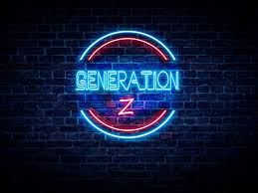**GENERAL REPORT ON GENERATION-Z CAREER ASPIRATIONS**

Submitted By: Abhishek K. Zine

**PROBLEM STATEMENT**

* Who is affected?
* What is happening?
* When is this happening?
* Where is this happening?
* 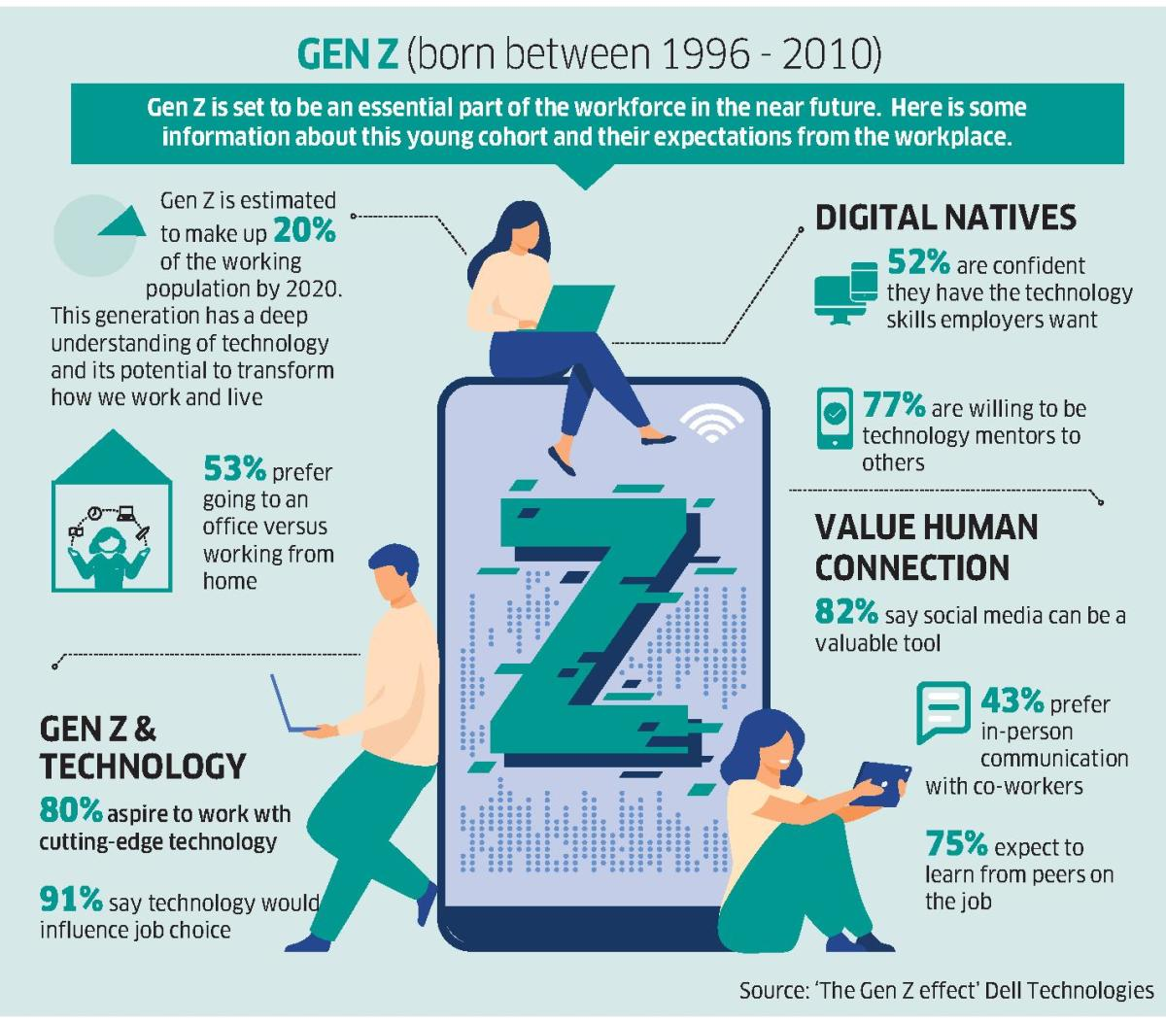Why is that a problem?

# *OBJECTIVE*

* Being Gen Z: My objective towards the life is getting well settled with having more income sources, positive approach on career track, making surroundings to be motivated, develop skills which will help throughout the career, and make life beautiful as much as possible.
* Making a positive impact: Gen Z values making a positive impact on the world and seeks careers that align with their values. They are interested in careers that promote social and environmental responsibility.
* Pursuing their passions: Gen Z tends to prioritize personal fulfillment and seeks careers that align with their interests and passions. They are interested in careers that allow them to be creative and express themselves.
* Continuous learning and growth: Gen Z values continuous learning and seeks careers that offer opportunities for personal and professional growth. They are interested in careers that allow them to learn new skills, take on new challenges, and advance their careers.
* Work-life balance: Gen Z values work-life balance and seeks careers that allow them to have flexibility in their work schedule. They are interested in careers that offer remote work options, flexible hours, and other work-life balance benefits.
* Financial stability: Gen Z is concerned about financial stability and seeks careers that offer competitive salaries and benefits. They are interested in careers that offer opportunities for financial growth and stability.

# *PERSPECTIVE TOWARDS PROBLEM STATEMENT*

Who is affected?

* The career aspirations of Generation Z may affect **employers**, as they may have different expectations from previous generations. For example, Generation Z tends to value work-life balance and flexible work arrangements. Therefore, employers may need to adapt their policies and practices to attract and retain Gen Z employees.
* Additionally, the career aspirations of Generation Z may impact the **education and training sector,** as they may be seeking more innovative and experiential learning opportunities. This may lead to changes in the way education and training are delivered, with a greater emphasis on technology and hands-on experiences.
* The career aspirations of Generation Z may impact **society** as a whole, as they may be more likely to pursue careers in fields that align with their values and passions, such as social justice and environmental sustainability. This may lead to a greater focus on these issues in the workplace and in society as a whole.

  

What is happening?

* Digital natives: Generation Z has grown up with technology and the internet as a constant presence in their lives, making them more adept at using and relying on technology than previous generations.
* Socially conscious: Gen Z is known for being more socially and environmentally conscious than previous generations. They are more likely to support causes related to social justice, climate change, and other important issues.
* Entrepreneurial spirit: Gen Z is also known for their entrepreneurial spirit, with many members of the generation starting their own businesses or side hustles.
* Diverse and inclusive: Gen Z is the most diverse generation in history, and they are more accepting of diversity and inclusivity than previous generations.
* Financially cautious: Gen Z is also more financially cautious than previous generations, as many of them have grown up during times of economic uncertainty and have witnessed the financial struggles of their parents and older siblings.

When is this happening?

* Generation Z is currently making its mark on society, as the oldest members of this generation are now in their early to mid-20s and beginning to enter the workforce. However, the characteristics and trends associated with this generation have been developing over the past decade or so, as they have grown up in a world that is vastly different from that of previous generations.

As a result, the impact of Generation Z on society and the workforce is expected to continue to grow and evolve in the coming years, as more members of the generation enter the workforce and become a larger part of the economy and society as a whole.

Where is this happening?

* The impact of Generation Z is being felt globally, as this generation represents a significant portion of the population in many countries around the world. However, the specific ways in which Gen Z is influencing society and the workforce may vary depending on the region and culture. For example, in some countries, Gen Z may be more focused on issues related to economic inequality and political unrest, while in others, they may be more focused on environmental sustainability or social justice. Similarly, the ways in which Gen Z is adapting to the changing job market and using technology may also vary depending on the region and the local economy. Overall, while the impact of Gen Z may be felt differently in different parts of the world, it is a global phenomenon that is shaping the future of society and the workforce worldwide.

Why is that a problem?

* Economic uncertainty: Many members of Gen Z are entering the workforce during a time of economic uncertainty, with fewer stable job opportunities and higher levels of debt than previous generations.
* Climate change and environmental degradation: Gen Z is growing up in a world where climate change and environmental degradation are major threats to their future well-being.
* Mental health and well-being: Gen Z are also facing high levels of stress and anxiety, with issues such as social media and the pressure to succeed exacerbating these problems.
* Political polarization: Gen Z is growing up in a world that is increasingly politically polarized, which can make it difficult to find common ground and work together on important issues.
* Inequality and social justice: Gen Z are also more aware of issues related to inequality and social justice, and they are pushing for change in these areas.